Shanley Philip
Doug Welch
CSCI 598D ML
Pattern Recognition Mini-project

Handwriting Recognition

Our goal with this mini-project was to train a computer to recognize handwriting! We simulated the handwriting using an open source image editor called GIMP. Each letter was created using the Sans font with a font size of 18 pixels. These settings were used to create 14x22 sized bitmaps of each letter in the English alphabet (a-z) . The training, cross-validation, and production data are included in the project files, along with our source code. Much of the code was based on an example provided by the teacher – backpropagation.cpp.

Method

The neural network we designed consisted of 322 input nodes – one node for each pixel of the letter bitmaps. The hidden layer and output layer consisted of 26 nodes, representing each of the 26 unique letters that the neural network would need to differentiate. Figure 1 is a visual representation of the implemented neural network. The answer is determined using a “winner takes all” philosophy, where the output with the largest value is the answer.

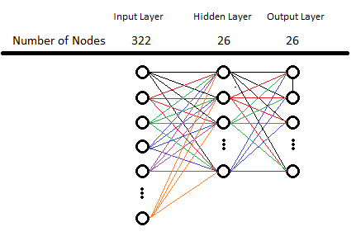
Figure 1: A graph showing the neural network used for the application of handwriting recognition. The number of nodes in the input layer is the number of pixels used to represent each character, whereas the number of letters in the English language determines the number of nodes in the output layer.

The value of each node in the hidden layer is calculated by simply taking the linear combination of the value of each node in the input layer and weights connecting the input node to a given hidden node. For each node in the hidden layer, the value of a node in the output layer is calculated by taking a linear combination of every node in the input layer and another set of weights. An additional step involves applying the sigmoid function to previously determined linear combination to keep the result between zero and one. The sigmoid function is defined as:
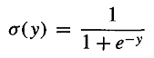
After processing the training image in the feed-forward network, the weights are back propagated from the output layer to the inputs nodes based on the expected value.

Back propagation adjusted the weight applied to the input from each node using the derivative of the sigmoid function, which is:
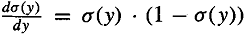
where y is the sum of each output value multiplied by their respective weights. This training process was repeated for randomly selected letters until the mean squared error (MSE) was less than 0.001. MSE is calculated by subtracting the actual value from the expected value and squaring the result.

After the network was trained using the training examples, the same process was used to apply the cross-validation data to the neural network. Then once the machine was prepared, a set of production data was evaluated and the machine performed quite impressively. In some cases it was able to recognize letters even with 25% noise level!

Implementation

The project is implemented using C++ and complied with g++ in a Linux environment. The letter bitmaps are black and white with RGB values ranging between 0 and 255. To simplify the training, these RGB values were compressed to 0 (white) and 1 (black). The Sans font used for this project is not perfect and as a result, there are several shades of gray present to represent the edges of each letter. To ensure that each letter is readable by human and computer, any pixel with a value greater than 113 is considered to be white and lower values are black. All weights have a random value between -0.5 and 0.5, initially.

The weights of each node in each layer were stored in a global variable to simplify the weight tracking for the feed forward and back propagation steps. The training and cross-validation portions both used the same feed forward network and back propagation steps while the production evaluation only used feed forward network to analyze each character so that the production results didn't influence the weights derived in training.

Results

During the brainstorming process to determine the types of characters to create for the production dataset, it was decided to test the neural networks ability to correctly classify characters after applying a translation, scaling, as well as varying amounts of noise. These factors seemed to be representative of situations that may arise naturally. We did 100 tests of each category, with the success reported below:

Surprisingly some of the original, untouched letters weren't recognized. This is probably due to over training with cross-validation data. Our machine didn't handle scaling or translation very well, so we decided to look into testing the noise level with varying amounts of noise from 5 to 50%. We averaged the results of 10 neural networks testing 1000 noisy images each and here's what we found:

Conclusion

We were quite happy with the results – it's actually surprising how quickly a neural network can be setup once the theory of it is understood. It seems like such a complex machine would take oodles of time to create, but it turns out that the real difficulty of the work which is the research was already taken care of. Of course there's much more research to be done, but what we were shown was adequate to design a simple neural network. And of course we had to go over the approach several times and refine it with the teacher. It also occurred to us that a hidden layer isn't completely necessary for the creation of a the neural network, so it would definitely be interesting to see how that hidden layer affects things. Overall it was fun, interesting and satisfying – a great note to end a project on!

